***Concepts of Operating System***

***Assignment 2***

***Part A***

***What will the following commands do?***

1. ***echo "Hello, World!"***

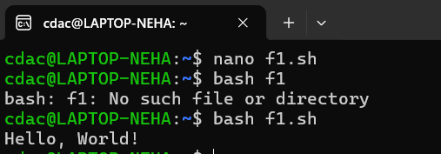

1. ***touch file.txt***

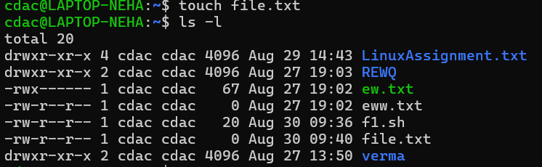

1. ***ls -a***



1. ***rm file.txt***

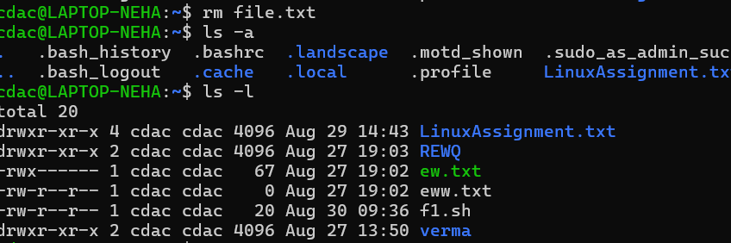

1. ***cp file1.txt file2.txt***

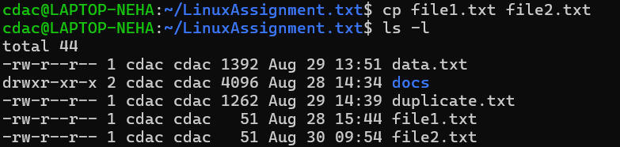

1. ***mv file.txt /path/to/directory/***



1. ***chmod 755 script.sh***

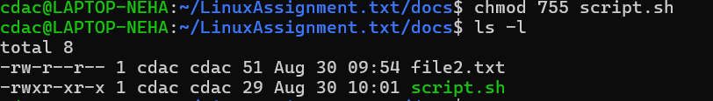

1. ***grep “pattern”***

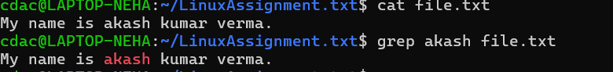

1. ***mkdir mydir && cd mydir && touch file.txt && echo "Hello, World!" > file.txt && cat file.txt***



1. ***ls -l | grep ".txt"***



1. ***cat file1.txt file2.txt | sort | uniq***

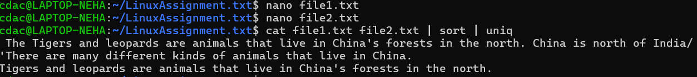

1. ***ls -l | grep "^d"***

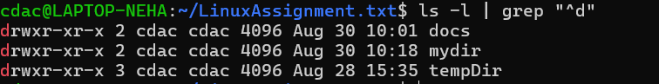

1. ***chmod -644 file.txt***

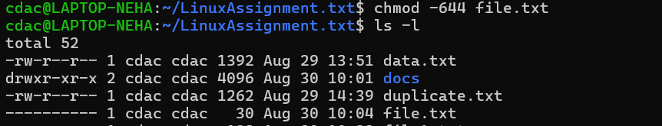

1. ***cp -r source_directory destination_directory***



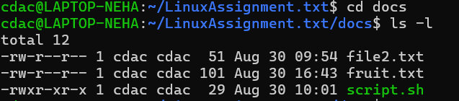

1. ***find /path/to/search -name "*.txt"***



1. ***chmod u+x file.txt***

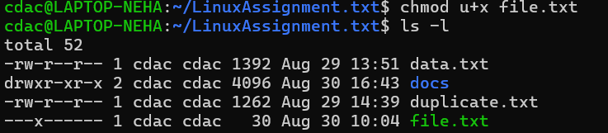

1. ***echo $PATH***



***Part B***

***Identify True or False:***

**1. ls is used to list files and directories in a directory.**

***ans . True***

**2. mv is used to move files and directories.**

***ans . True***

**3. cd is used to copy files and directories.**

***ans . False***

**4. pwd stands for "print working directory" and displays the current directory.**

***ans . True***

**5. grep is used to search for patterns in files.**

***ans . True***

**6. chmod 755 file.txt gives read, write, and execute permissions to the owner, and read and execute permissions to group and others.**

***ans . True***

**7. mkdir -p directory1/directory2 creates nested directories, creating directory2 inside directory1 if directory1 does not exist.**

***ans . True***

**8. rm -rf file.txt deletes a file forcefully without confirmation.**

***ans . True***

**Identify the Incorrect Commands:**

**1. chmodx is used to change file permissions. = Correct**

**2. cpy is used to copy files and directories. = Incorrect**

**3. mkfile is used to create a new file. = Incorrect**

**4. catx is used to concatenate files. = Incorrect**

**5. rn is used to rename files. = Correct**

**Part C**

***Question 1: Write a shell script that prints "Hello, World!" to the terminal.***

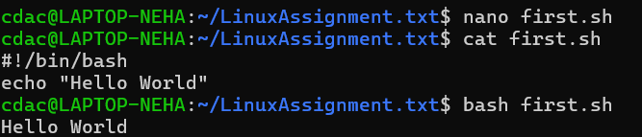

***Question 2: Declare a variable named "name" and assign the value "CDAC Mumbai" to it. Print the value of the variable.***

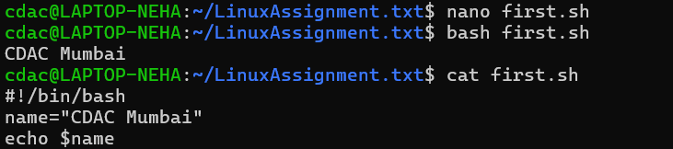

***Question 3: Write a shell script that takes a number as input from the user and prints it.***

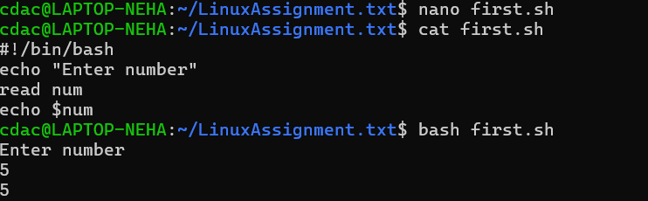

***Question 4: Write a shell script that performs addition of two numbers (e.g., 5 and 3) and prints the result.***

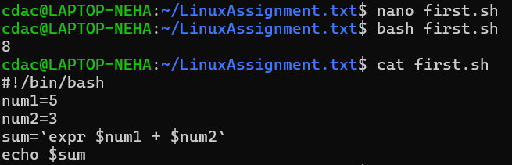

***Question 5: Write a shell script that takes a number as input and prints "Even" if it is even, otherwise prints "Odd".***

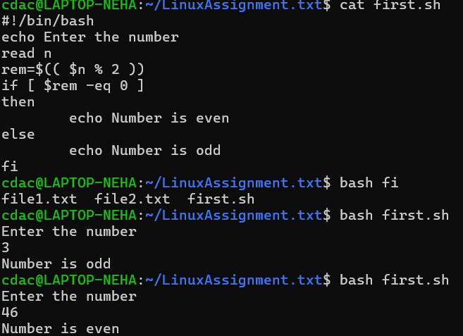

***Question 6: Write a shell script that uses a for loop to print numbers from 1 to 5.***

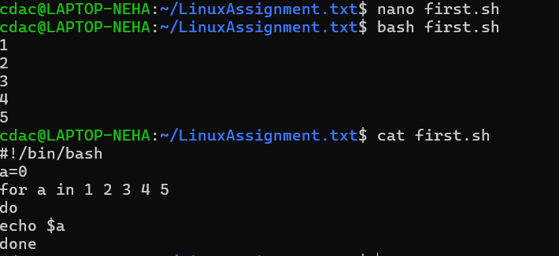

***Question 7: Write a shell script that uses a while loop to print numbers from 1 to 5.***

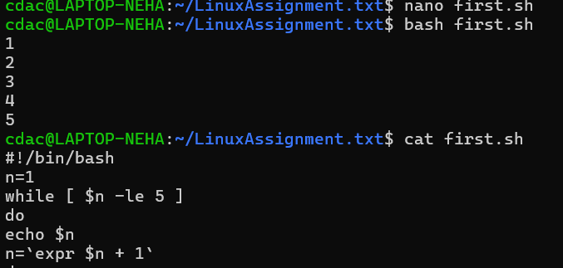

***Question 8: Write a shell script that checks if a file named "file.txt" exists in the current directory. If it does, print "File exists", otherwise, print "File does not exist".***

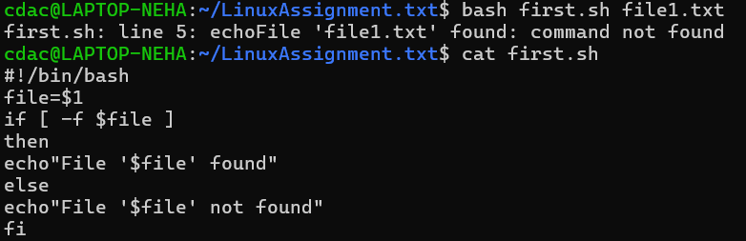

***Question 9: Write a shell script that uses the if statement to check if a number is greater than 10 and prints a message accordingly.***

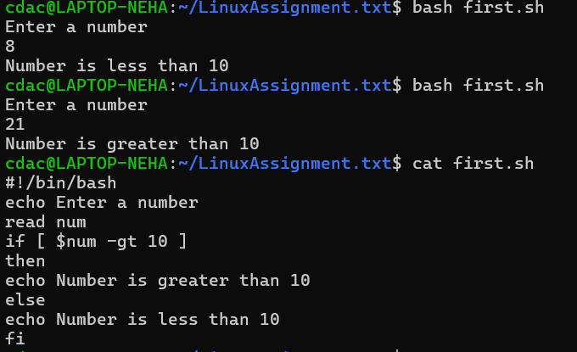

***Question 10: Write a shell script that uses nested for loops to print a multiplication table for numbers from 1 to 5. The output should be formatted nicely, with each row representing a number and each column representing the multiplication result for that number.***

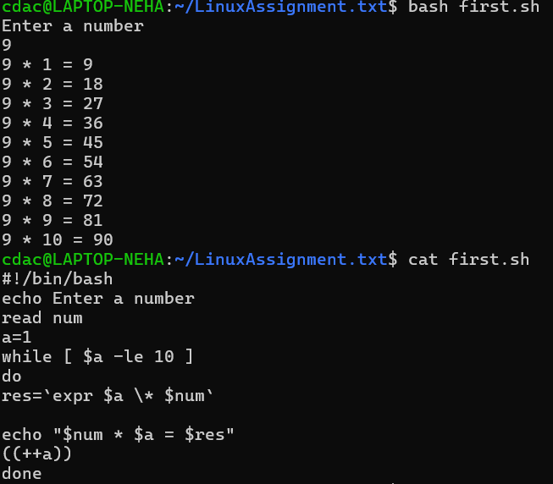

***Part E***

***1. Consider the following processes with arrival times and burst times:***

***| Process | Arrival Time | Burst Time |***

***|---------|--------------|------------|***

***| P1 | 0 | 5 |***

***| P2 | 1 | 3 |***

***| P3 | 2 | 6 |***

***Calculate the average waiting time using First-Come, First-Served (FCFS) scheduling.***

***2. Consider the following processes with arrival times and burst times:***

***| Process | Arrival Time | Burst Time |***

***|---------|--------------|------------|***

***| P1 | 0 | 3 |***

***| P2 | 1 | 5 |***

***| P3 | 2 | 1 |***

***| P4 | 3 | 4 |***

***Calculate the average turnaround time using Shortest Job First (SJF) scheduling.***

***3. Consider the following processes with arrival times, burst times, and priorities (lower number***

***indicates higher priority):***

***| Process | Arrival Time | Burst Time | Priority |***

***|---------|--------------|------------|----------|***

***| P1 | 0 | 6 | 3 |***

***| P2 | 1 | 4 | 1 |***

***| P3 | 2 | 7 | 4 |***

***| P4 | 3 | 2 | 2 |***

***Calculate the average waiting time using Priority Scheduling.***

***4. Consider the following processes with arrival times and burst times, and the time quantum for***

***Round Robin scheduling is 2 units:***

***| Process | Arrival Time | Burst Time |***

***|---------|--------------|------------|***

***| P1 | 0 | 4 |***

***| P2 | 1 | 5 |***

***| P3 | 2 | 2 |***

***| P4 | 3 | 3 |***

***Calculate the average turnaround time using Round Robin scheduling.***

